# CS 255 Driver Pass System Design Document

Brian Fulton

## UML Diagrams

### UML Use Case Diagram

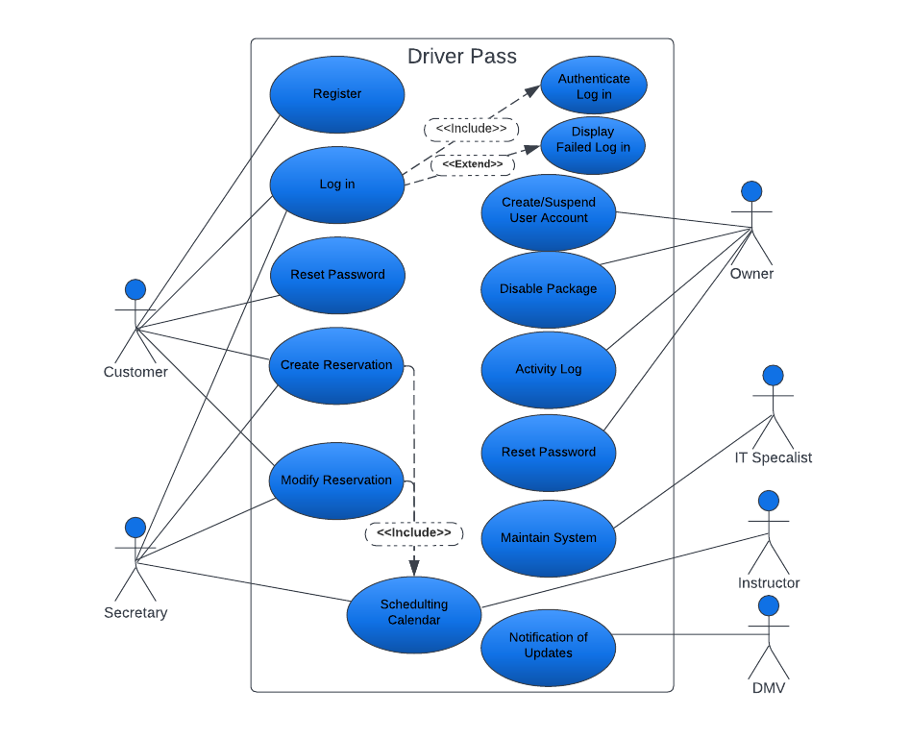

### UML Sequence Diagram

### UML Class Diagram

## Technical Requirements

The Driver pass system is a cloud hosted web site requiring the Linux Digtal Ocean PaaS offerings. Scalability is necessary for the increased cloud data held when more students book appointments and if more instructors are hired to support an increase in customer base. The cloud hosted site will allow Driver pass employees to focus on their business and leave the security, scaling, and most of the back end to the service provider. The system is able to run on a variety of systems and every operating system. Some of the clients of Driver pass won’t access the web-based site and a physical office with a secretary is necessary so that the secretary may book appointments for those customers. The owner wishes to download activity reports and other info from the site whenever he wishes. Digital ocean will store the data and a separate back end log in will be designed for the owner to perform these tasks.